CO2 Foodprint: Carbon Footprint Calculator

Members: Soma Badri (product owner), Riley Murphy, Destin Wong, Raymond Lee (scrum master), Kelley Broderick

Sprint Date: Weeks 8-10

Revision Number: 2

Revision Date: May 20, 2021

TA: yogolan@ucsc.edu

**Scale for Story Points**

1: X small

2: Small

3: Medium

5: Large

8: X Large

13: XXL

20/21: Huge

Sprint 4

|  |  |  |
| --- | --- | --- |
| Goal  (*) = reach | Story Points | Priority |
| As a user, I want to be able to save recipes that I have viewed from others to see/use later on   * Be able to see other users & get to their pages, follow them so it saves their profile to your friends (4 hrs) * Make other user profile page UI (pic, name, recipes) (2 hrs) * Save their recipe to your list (2 hrs) * See how many people saved **your** recipes and how many followers you have (*) (1 hr) | 20 | 1 |
| As a user I want to be able to see other user’s posts on the dashboard so that I can see what others are doing and like or follow those users   * Other people’s posts go to dashboard (2 hrs) * Be able to click on these posts and go to their profile (1 hr) | 13 | 2 |
| As a user, I want to be able to view the site on mobile so I can view it any time   * Restructure for mobile (3 hrs) | 20 | 3 |
| As a developer, I want somewhere to host our website   * Firebase (<1 hr) | 20 | 4 |

Total ~16 hrs

Initial Task assignment:

Riley: backend functionality, add friend

Destin: backend functionality, delete friend

Soma: mobile, make pretty, Firebase

Raymond: mobile

Kelley: friend page UI, backend functionality

Burnup Chart:

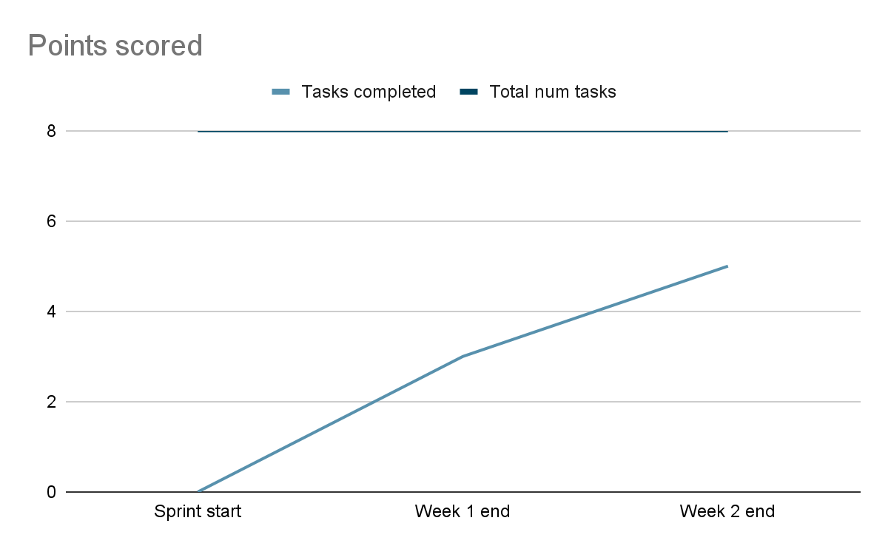

|  |  |  |  |
| --- | --- | --- | --- |
| Tasks | Not started | In progress | Complete |
| Be able to see other users & get to their pages, follow them so it saves their profile to your friends |  |  | x |
| Make other user profile page UI (pic, name, recipes) |  |  | x |
| Save their recipe to your list |  |  | x |
| See how many people saved **your** recipes and how many followers you have (reach *) | x |  |  |
| Other people’s posts go to dashboard |  |  | x |
| Be able to click on these posts and go to their profile |  |  | x |
| Restructure for mobile |  | x |  |
| Firebase | x |  |  |
|  |  |  |  |

Scrum board:

Sundays 1pm

Tuesdays 3-4 (with TA)

Thursdays 10:30am